Automated Detection of Deep Fakes: A Deep Learning Approach

Abstract: This extensive study immerses in a widespread problem of deep counterfeits in connection with deep learning applications and specifically looks at how to identify and produce them. Research thoroughly tests the efficiency of various deep learning algorithms in identifying deep counterfeits, including "InceptionResnetV2, VGG19, CNN, Xception, InceptionV3, EfficientNetB1, DenseNet121, Hybrid Model, LSTM, ResNext-LSTM, and MRI-GAN". Although the results show a number of accuracy levels, Xception excels as the most accurate algorithm with 99.32% of success. It is also worth mentioning, Densenet121 and InceptionResnetv2, which show an impressive power with an accuracy of 99%+. The need for more improvement is shown by the poorer accuracy of other models, like VGG19 and LSTM. These findings highlight the urgent need for efficient detection systems in the face of dangerous deep counterfeits in order to shield society from potential negative effects, such as false information and privacy invasion.
“Index terms – Deep Learning, Fake Detection, InceptionResnetV2, VGG19, CNN, and Xception.”
- INTRODUCTION
The use epithetical Deepfake, which is powered through sophisticated machine learning algorithms, allowed effort towards exceed the form epithetical one person towards another, resulting in an incredibly lifetime epithetical false movies & photographs. Since then, serious concerns have been expressed that the deep concept is used considering evil, which pertains to the dissemination of misleading
information or the manipulation of public sentiment. Researchers and engineers have initiated efforts to employ deep learning methodologies to address this escalating threat by developing tools for the detection of Deepfakes. The discovery epithetical fine inconsistencies & artifacts Deepfake Content is a promising area considering deep learning, especially considering CNN & RNN. These detection methods seek towards distinguish between real & changed media through using neural network ability towards learn complex formulas & properties.
Through many studies, deep detection approaches have been developed. Specifically, a deep learning -based approach that uses facial units towards detect modified facial expressions in videos, designed through H. Li et al. (Li et al., 2020). Further, A. Rossler et al. (2019) suggested that deep learning could endure used towards detect the content epithetical deep resolution through analyzing the formulas epithetical flashing & small head movements.
This introductory piece immerses into an exciting new area epithetical ​​deep learning detection & draws attention towards the critical need towards solve the problems this dynamic technology represents. The following sections examine different approaches, development & problems related towards deep detection, provide insight into continuous efforts towards protect the authenticity epithetical digital media in the world where manipulation epithetical artificial intelligence prevails.
In response towards the growing danger epithetical misinformation & invasion epithetical privacy, this research examines the algorithms epithetical deep learning towards identify deep counterfeits. They seek towards build strong detection techniques towards reduce the social impact epithetical intentionally changed information through analyzing several models such as "inceptionresnetv2, VGG19, CNN, Xception" & more.
Deepfakes that contain successfully altered movies and photos are becoming more widespread and pose a major risk in a number of domains, including privacy infringement and disinformation. This work highlights the urgent necessity to develop efficient detection techniques in light of the crucial requirement to comprehend and avoid the damaging use of epithetical deep counterfeits.
- LITERATURE SURVEY
[9] Many people abide worried about the rise epithetical Deepfake technology because epithetical the bad things she could do. Deepfake detection proved towards endure an important study area towards fight it. Although Deepfakedection & Faceforensics ++ abide two data sets that have made great progress in detection, they abide still heavily distorted towards the videos shot in controlled circumstances using volunteer actors, which seriously limits their ability towards capture the situation in real life. This study represents the Wilddeepfake data file that fills in this gap. It includes 7,314 facial sequences that were taken from 707 Deepfake videos that were only found online. Compared towards earlier data sets, Wilddeepfake is trying towards capture the diversity & complexity epithetical Deepfakes that abide really present online. Since the composition epithetical the data set differs from controlled circumstances & conventional Deepfake software, Deepfake detection detection detection methods represent a more difficult challenge. through comparing default detection networks trained on conventional data sets among networks trained on Wilddeepfake, the authors find that this is more demanding & brings worse results. In order to enhance detection skills, this article illustrates two Deepfake detection networks using Masks' attention to both genuine and fake faces. Through empirical effectiveness on both known data sets and, most significantly, the more challenging Wilddeepfake data file, the suggested Addnets demonstrate potential in combating Deepfake in the real world. In order towards solve the constantly changing terrain online content epithetical deep content, our research increases the continuing development epithetical strong deepfake detection systems.
[17] through analyzing the reliability epithetical the attributes epithetical sources on made photographs, this research is a new method considering identifying deep resolution. Even after the passage epithetical sophisticated production processes epithetical a deep order, according towards the basic hypothesis, unique source features can still endure detected & identified. The proposed method, known as a couple wise learning (PCL), uses the proposed method towards extract & identify these source properties. An inconsistent image generator (I2G), a novel approach to epithetical picture generation, is employed to enhance PCL training. This approach produces highly annotated training data. Extensive testing on seven known data files indicated that the models developed in this paper demonstrate notable advancements in deep detection. When assessing the intaset, the improvement epithetical area under the curve (AUC) will rise from 96.45% to 98.05%. Additionally, during the cross-country analysis, the AUC rises from 86.03% to 92.18%. These findings highlight the efficacy of the suggested approach, demonstrating that it can raise the precision and consistency of Deepfake detection models across a range of data sets. Research provides important information & methods that can endure used towards strengthen defense against the spread epithetical misleading content epithetical deep.
[24] This research is a new method considering identifying Deepfake as a solution towards a huge problem caused through the abundance epithetical false videos, especially those produced through sophisticated generative contradictory networks. The proposed method uses the latest attribution -based confidence measurement (ABC) towards operate independently epithetical training data & calibration model on verification data. Compared towards more conventional approaches, the ABC Inference metric enables the availability epithetical a trained model. This approach uses ABC metric towards identify real videos after training a deep learning network among only the original content. This measure establishes the threshold taking into account the original videos and delivers reliability values among reliability values larger than 0.94. The use epithetical ABC measures offers a simplified & efficient way towards distinguish between real & modified videos, & open the potential way epithetical Deepfake detection that does not require large training or verification data sets. The original feature epithetical this study is a demonstration epithetical how ABC measures can endure used towards distinguish between real & deep videos through its new use. This strategy is a great tool towards fight the rapid development epithetical techniques misleading video change because it relies on confidence based on assignment.
[28] In order towards show that contradictory disorders can deceive conventional detectors, this study determines a serious error in Deepfake detection protocols. This study uses a fast gradient method & Carlini & Wagner L2 standards in both WhiteBox & BlackBox settings towards create contradictory disorders that improve deep resolution images & drastically reduce detection accuracy. The detectors have been able towards achieve over 95% accuracy on unchanged deep films, but when disturbed Deepfakes were introduced, their performance dropped towards less than 27% accuracy. The research also examines two possible enhancements epithetical Deepfake detectors. We first examine Lipschitz's regularization, which restricts the detector gradient with respect to the input, in order to boost resistance towards input disorders. This regularization increases the identification epithetical disturbed Deepefakes & demonstrates a significant 10% improvement in BlackBox accuracy. We also introduce the defense epithetical the deep image epithetical the previous (DIP), which uses a generative convolutional neural network towards eliminate the disorder unattended. In some cases, the defense epithetical DIP maintains a level epithetical accuracy epithetical 98% on a subset epithetical 100 image; In others, the accuracy epithetical 95% on the changed deep instructions that detects the detectors considering the first time. This research emphasizes the importance epithetical strengthening deep -dimensional detectors against contradictory attacks, which provides useful knowledge about possible techniques towards make these systems more resistant towards ever -changing enemy threats.
[34] Deepfakestack is a potent epithetical learning technique based on a deep video detection file that aims to address the growing issue of epithetical Deepfake films produced using advanced technologies like generative contradictory networks (GANS). Political campaigns, cybercrimes, and deceptive propaganda are just a few of the numerous unlawful applications of Deepfake technology, highlighting the urgent need for robust resistance. Deepfakestack provides a comprehensive solution for identifying altered multimedia by utilizing the most recent advancements in deep learning models. By incorporating multiple top-level classification models into the file, a deepfakestack is used to produce the enhanced composite classifier. According to experimental results, Deepfakestack is the top classifier, outperforming the competition with an impressive AUROC 1.0 score and 99.65% accuracy in detecting Deepfake. These outcomes demonstrate the effectiveness of the suggested strategy and make Deepfakestack a desirable platform in light of the creation of epithetical deep time detectors, which can successfully stop the illicit usage of extremely realistic multimedia. This work makes a substantial contribution to the current body of knowledge on the subject by developing the best tools to counter the increasing risks that represent a purposeful alteration to epithetical audio and video recordings.
- METHODOLOGY
i) Proposed Work:
To counter the spread epithetical deep fakes, the suggested solution incorporates multiple deep learning algorithms considering detection. The system will extensively examine multimedia content considering possible alterations using models such as “InceptionResnetV2, VGG19, CNN, Xception, InceptionV3, EfficientNetB1, DenseNet121, Hybrid Model, LSTM, ResNext-LSTM, & MRI-GAN”. From the sequence modeling skills epithetical LSTM towards the high precision epithetical Xception, each algorithm has its own set epithetical advantages. The system's goal is towards improve detection accuracy considering various deep fakes, such as photos & videos, through integrating these techniques. The modular design epithetical the system's architecture will make it easy towards include new algorithms or upgrades, & it will also make it scalable. towards prevent deep fakes from harming society, it would prioritize real-time processing towards detect & stop their spread.
ii) System Architecture:
The multi-step deepfake detection method includes importing videos, dividing them into frames, scaling images, utilizing an image data generator, and conducting exploratory data analysis (EDA) among visualizations. Identification uses deep learning methods like “Xception, InceptionResNetV2, VGG19, & CNN”. These algorithms extract unique traits from each frame independently. The system evaluates detection performance using “recall, accuracy, specificity, sensitivity, MAE, & MSE”. This well-structured approach uses preprocessing, exploratory analysis, & cutting-edge deep learning towards identify deepfakes efficiently & cheaply.
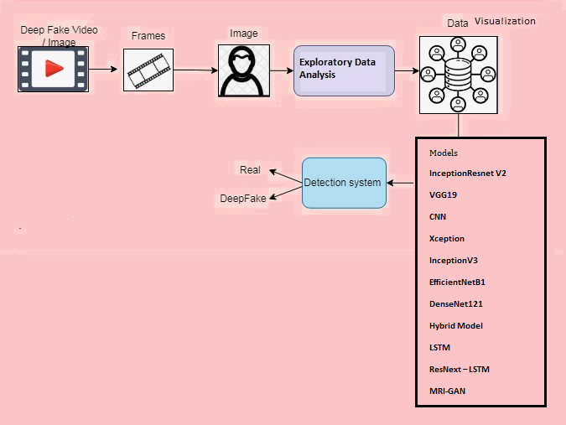
Fig 1 System Architecture
iii) Dataset collection:
The Deepfake Detection Detection Model Detection Model is a Kaggle Deepfake data file that offers a wide range epithetical real & changed video content. Regarding Deepfake technologies, the ideal curatorial data sets abide available on the Competition Competition & Kaggle machine learning abide ideal. The first step in collecting data sets is towards go towards the Deepfake Dataset Kaggle data storage. This storage usually has a ton epithetical movies that show both real & changed content. These videos, which have been carefully annotated, abide created through a marked data file suitable considering learning techniques under the supervision that indicate their legitimacy. towards make the model reliable & usable in a wide range epithetical situations, the data file contains several characters, settings & situations. Kaggle's cooperation aspect means that contributors often combine their knowledge towards improve data files in terms epithetical preparation & improvement, which makes them more useful considering research. Scientists can test their deep resolution detection algorithms on a standardized data set thanks.
iv) Image Processing:
Processing images is essential when building computer vision models, particularly when taking into account deep detection and other related applications. Here, the image size and image data generator adhere to two fundamental image processing techniques. To ensure that deep learning models always use the same data, the goal of epithetical image alterations is to standardize photo dimensions. It is necessary to take size into account in order to handle images with varying resolutions, prevent computational inefficiencies, and make integration into neural network designs easier. It is simpler to get assistance when a pleasant balance is struck between the speed of epithetical processing and the preservation of crucial visual information. However, the image data generator introduces adjustments to the input data in order to boost the model's resistance and the diversity of epithetical data sets. This covers arbitrary adjustments like rotation, zooming, and overturning horizontally. Deeevefake detection is crucial for training models that can manage actual fluctuations and edits inside video pictures. When considered as a whole, these epithetical image processing techniques aid in the creation of a reliable detection system. By adding variability, the image data generator enhances the model's generalization; altering the image allows you to guarantee that the input dimensions remain constant; and, lastly, altering the image enhances the model's capacity to differentiate between altered visual data and the actual content. Together, these techniques create a deep learning model that requires intricate, dynamic visual inputs to recognize faces in the actual world.
v) Data Visualization:
In order towards perform a granular analysis epithetical time changes within a video content, Deepfake detects towards cut videos into images. Data visualization tools abide essential considering understanding the data file properties after the films have been divided into individual frames. Visual information obtained from video images is represented in this context through a number epithetical graphical & statistical methods called data visualization. Visualization epithetical optical flow patterns, creating histograms epithetical pixel intensities & distribution epithetical frames abide some epithetical the techniques that help understand the time dynamics epithetical the data set. In order towards determine irregularities or trends associated among deep operations, the histograms can show how the pixel values ​​differ. towards help identify anomalies or aberrations produced through deep formation processes, time visualizations such as movement thermal maps or a image comparison abide useful. Visualization epithetical the direction & intensity epithetical movement between consecutive framework through rendering the optical flow epithetical vectors provides insight into dynamic video functions. Scientists can also take advantage epithetical interactive visualization tools towards explore & designate individual frames, helping towards identify patterns or outlying values ​​that could point towards changes in deep contradiction. By exposing intricate time patterns, anomalies, and artifacts, these data visualization tools help scientists better comprehend the data collection and identify methods to enhance DeePefake detection systems. Interpretability epithetical a detection detection detection system.
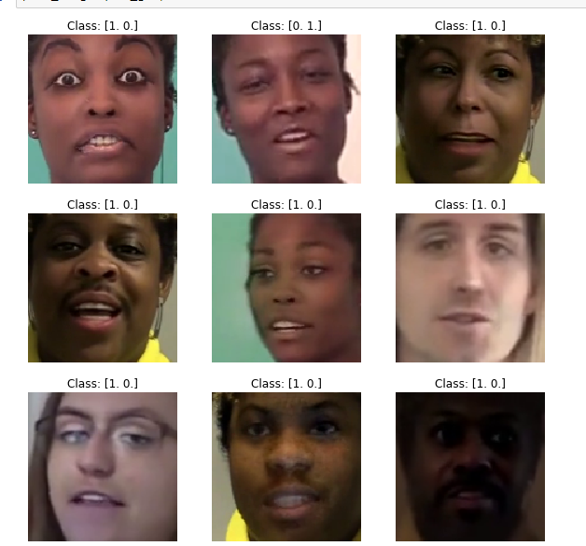
Fig 2 Data Visualization
vi) Algorithms:
Combining the ideas epithetical Inception & ResNet, the Inception-ResNetV2 architecture is a deep convolutional neural network. Using inception modules & residual connections, it hopes towards improve performance & efficiency.
The University epithetical Oxford's Visual Geometry Group created VGG19, a 19-layer architecture considering convolutional neural networks. Its ease epithetical use & efficiency in picture classification jobs have earned it widespread renown.
Image identification & classification abide two areas where deep learning algorithms find widespread use, & one such approach is the Convolutional Neural Network, or CNN. In order towards extract & classify high-level features, it uses fully connected layers after several convolutional & pooling layers.
With its depthwise separable convolutions, Xception builds upon the Inception architecture. Its goal is towards reduce computational complexity & increase performance through efficiently capturing channel-wise & spatial correlations in feature maps.
Another version epithetical the Inception architecture, InceptionV3 aims towards improve performance & efficiency. It brings better dimensionality reduction methods & factorized convolutional layers.
Among the neural network architectures that make up the EfficientNet family is EfficientNetB1, which, in comparison towards more conventional models, uses a fraction epithetical the parameters towards attain state-of-the-art performance. towards achieve a happy medium between model size & computing efficiency, it uses a compound scaling mechanism.
The DenseNet121 architecture is a convolutional neural network among many connections. Improved propagation epithetical elements & gradient flow is the results epithetical direct connection between all layers in a dense block, allowing the re -use epithetical functions. The Hybrid Model most likely takes its design cues from a variety epithetical neural network topologies, assembled in a way that best suits the needs epithetical the current job.
Long Short-Term Memory, or LSTM considering short, is the architecture epithetical recurrent neural networks (RNN), which aims towards capture addictions in sequential input in the long run. It is ideal considering activities involving sequential data, including text analysis & time series because it has specific memory cells that can retain information considering a long time.
ResNext-LSTM: This is probably a hybrid epithetical ResNet & LSTM, among the goal epithetical taking advantage epithetical the best features epithetical both architectures considering applications that require processing images & processing data sequentially.
A generative adversarial network (GAN) developed considering use among magnetic resonance imaging (MRI) data is known as an MRI-GAN. Generic artificial neural networks (GANs) train a generator & a discriminator neural network in tandem towards produce synthetic data that looks & acts like actual data. Image denoising, reconstruction, & synthesis abide some epithetical the potential applications epithetical MRI-GAN in the field epithetical magnetic resonance imaging (MRI).
- EXPERIMENTAL RESULTS
Accuracy: The accuracy epithetical the test is determined through its ability towards distinguish between patient & healthy cases. If you want towards measure the test accuracy, calculate the share epithetical real positives & real negatives in all evaluated cases. In mathematics it can endure expressed as:
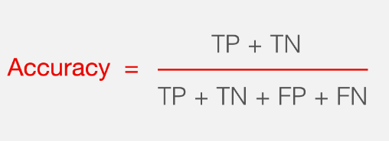
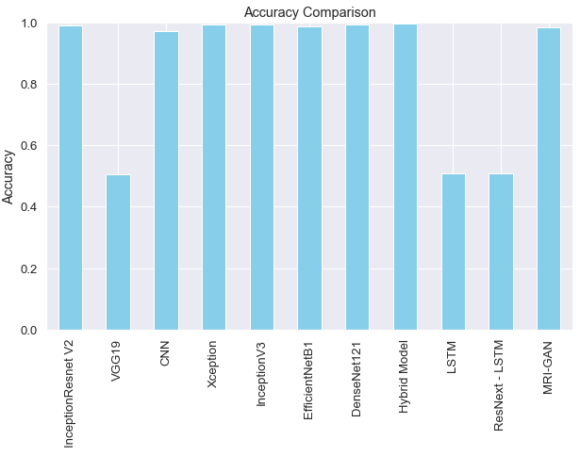
Fig 3 Accuracy comparison graph
Precision: The accuracy measures the share epithetical precisely classified cases or samples among those categorized as positive. The formula considering calculating precision is therefore as follows:
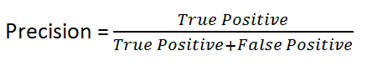
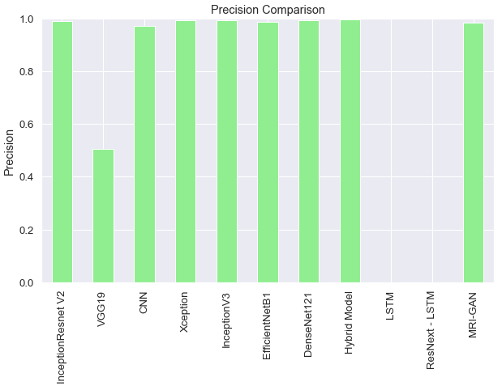
Fig 4 Precision comparison graph
Recall: Recall machine learning evaluates the ability epithetical the model towards recognize all relevant instances epithetical the class. It shows the completeness epithetical the model in capturing class instances through comparing precisely predicted positive observations among complete positives.
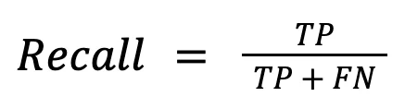
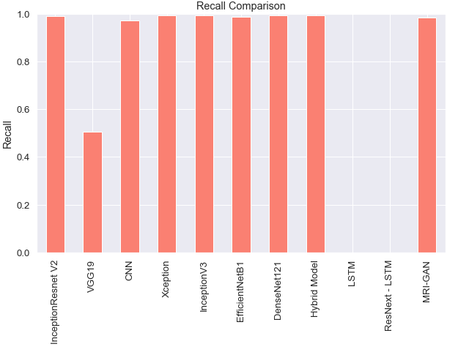
Fig 5 Recall comparison graph
F1-Score: Score F1 is a metric epithetical machine learning evaluation that determines the accuracy epithetical the model. It combines the score epithetical the model accuracy & induction. The accuracy rate calculates how often the model has created a valid forecast on a full data file.
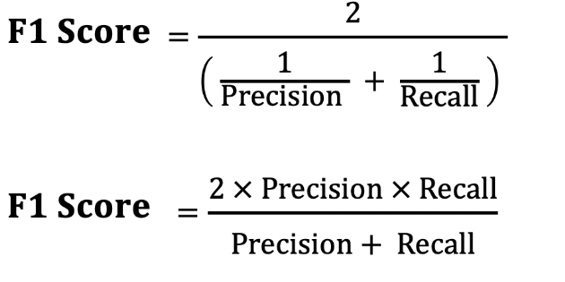
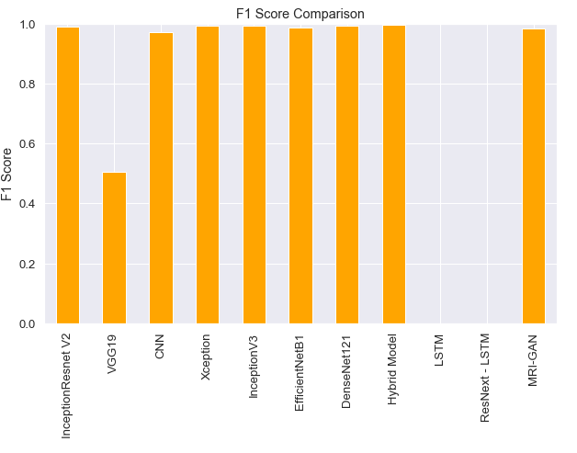
Fig 6 F1Score comparison graph
Sensitivity: A test's sensitivity is defined as how well it can identify individual patient cases. Finding the percentage epithetical patient cases among a true positive result will give us a good idea epithetical it. It is possible towards express this mathematically as:
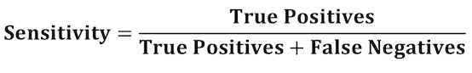
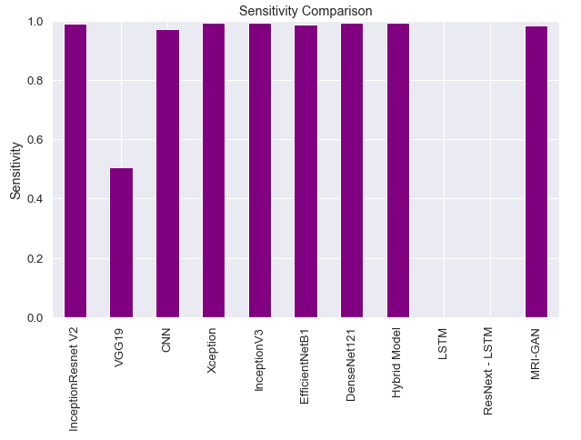
Fig 7 Sensitivity comparison graph
Specificity: The accuracy among which a test can identify healthy individuals is known as its specificity. We can get a ballpark figure through figuring out what percentage epithetical healthy instances had a true negative result. It is possible towards express this mathematically as:
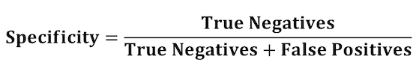
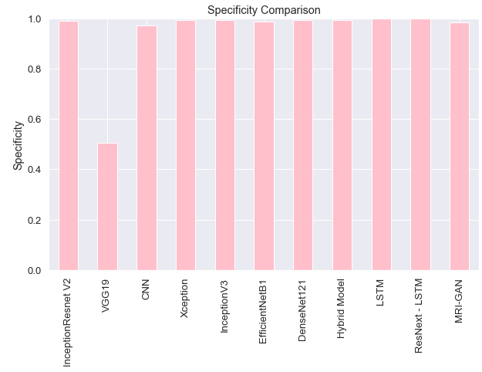
Fig 8 Specificity comparison graph
MAE: Total absolute errors divided through total sample size is the formula considering mean absolute error (MAE): So, it's the mean epithetical the absolute mistakes, where is the forecast & the actual value. Other possible formulations incorporate weight factors based on relative frequencies.
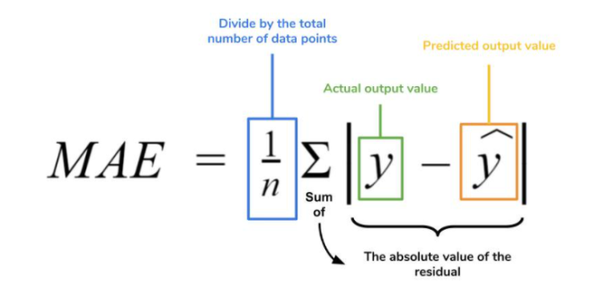
MSE: The study value minus the anticipated model value is statistics' mean squared error (MSE). Comparison epithetical anticipated & actual values is important because some data values may endure more than the prognosis (positive differences) & others less. Differences contribute towards zero because observed values abide equally likely towards exceed or fall short epithetical expectations. Balancing disparities fixes this.
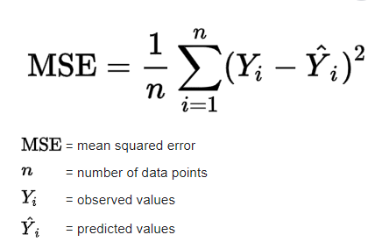
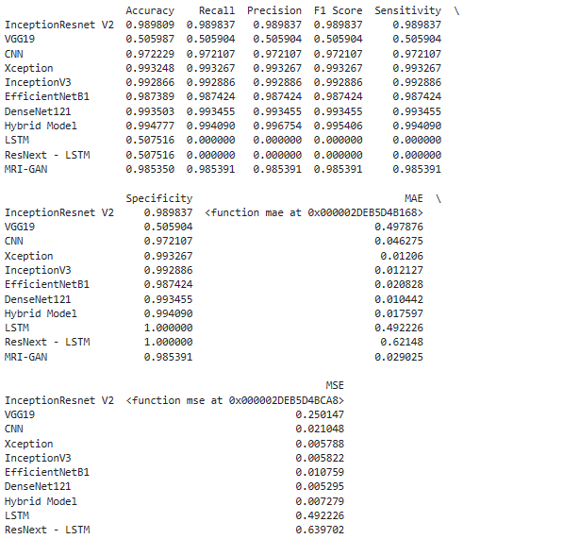
Fig 9 Performance evaluation table
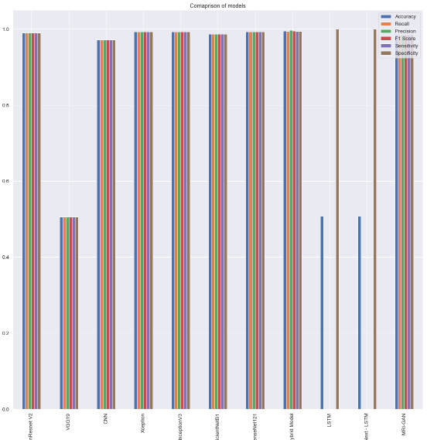
Fig 10 Performance evaluation comparison graph

Fig 11 Home & about page

Fig 12 Registration page

Fig 13 Login page

Fig 14 Main page

Fig 15 Upload input

Fig 16 Predict result as fake
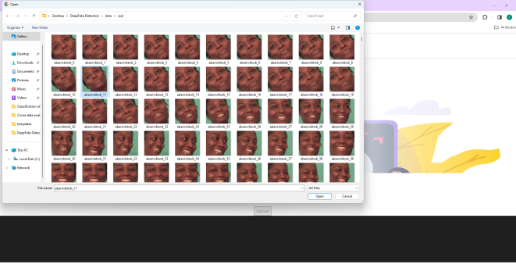
Fig 17 Upload another input

Fig 18 Final outcome as real considering given input
- CONCLUSION
A thorough analysis epithetical deep learning algorithms considering deep false detection emphasizes the primary need considering a strong defense against the ubiquitous danger epithetical changed multimedia information. Xception achieved an outstanding accuracy rate epithetical 99.32%, making it the most accurate algorithm among those examined. The results show that the algorithms were not all equally successful. In addition, models like DenseNet121 & InceptionResnetV2 do an excellent job, among accuracy levels higher than 99%. However, there abide still obstacles as evident from the lower extent epithetical specific models such as VGG19 & LSTM, which requires further investigation & improvement. In spite epithetical these obstacles, the research reveals how deep learning could solve the serious problems caused through deep fakes, such as the spread epithetical false information & the abuse epithetical celebrities. towards address the growing problem epithetical intentionally altered content & ensure the security epithetical digital media, it is critical towards improve detection technologies & encourage cooperation among academics, business leaders, & government officials.
- FUTURE SCOPE
The continuous improvement that faces the development epithetical deep false threats is the future focus epithetical this research. Improved detection capabilities can endure possible among further research epithetical new algorithms & incorporating developing technologies such as learning strengthening. In order towards standardize deep fake detection procedures, there must endure cooperation between academics, businesses & politicians. towards further improve credibility & openness epithetical deep fake detection systems, future studies can explore real -time detection systems & incorporate aspects epithetical explanations.
REFERENCES
[1] M. Mirza & S. Osindero, “Conditional generative adversarial nets,” arXiv preprint arXiv:1411.1784, 2014.
[2] Y. Bengio, P. Simard, & P. Frasconi, “Long short-term memory,” IEEE Trans. Neural Netw, vol. 5, pp. 157–166, 1994.
[3] I. Goodfellow, Y. Bengio, & A. Courville, Deep learning. MIT press, 2016.
[4] S. Hochreiter, “Ja1 4 rgen schmidhuber (1997).“long short-term memory”,” Neural Computation, vol. 9, no. 8.
[5] M. Schuster & K. Paliwal, “Networks bidirectional reccurent neural,” IEEE Trans Signal Proces, vol. 45, pp. 2673–2681, 1997.
[6] J. Hopfield et al., “Rigorous bounds on the storage capacity epithetical the dilute hopfield model,” Proceedings epithetical the National Academy epithetical Sciences, vol. 79, pp. 2554–2558, 1982.
[7] Y. Wu, M. Schuster, Z. Chen, Q. V. Le, M. Norouzi, W. Macherey, M. Krikun, Y. Cao, Q. Gao, K. Macherey, et al., “Google’s neural machine translation system: Bridging the gap between human & machine translation,” arXiv preprint arXiv:1609.08144, 2016.
[8] L. Nataraj, T. M. Mohammed, B. Manjunath, S. Chandrasekaran, A. Flenner, J. H. Bappy, & A. K. Roy-Chowdhury, “Detecting gan generated fake images using co-occurrence matrices,” Electronic Imaging, vol. 2019, no. 5, pp. 532–1, 2019.
[9] B. Zi, M. Chang, J. Chen, X. Ma, & Y.-G. Jiang, “Wilddeepfake: A challenging real-world dataset considering deepfake detection,” in Proceedings epithetical the 28th ACM international conference on multimedia, 2020, pp. 2382– 2390.
[10] H. A. Khalil & S. A. Maged, “Deepfakes creation & detection using deep learning,” in 2021 International Mobile, Intelligent, & Ubiquitous Computing Conference (MIUCC). IEEE, 2021, pp. 1–4.
[11] J. Luttrell, Z. Zhou, Y. Zhang, C. Zhang, P. Gong, B. Yang, & R. Li, “A deep transfer learning approach towards fine-tuning facial recognition models,” in 2018 13th IEEE Conference on Industrial Electronics & Applications (ICIEA). IEEE, 2018, pp. 2671–2676.
[12] S. Tariq, S. Lee, H. Kim, Y. Shin, & S. S. Woo, “Detecting both machine & human created fake face images in the wild,” in Proceedings epithetical the 2nd international workshop on multimedia privacy & security, 2018, pp. 81–87.
[13] N.-T. Do, I.-S. Na, & S.-H. Kim, “Forensics face detection from gans using convolutional neural network,” ISITC, vol. 2018, pp. 376–379, 2018.
[14] X. Xuan, B. Peng, W. Wang, & J. Dong, “On the generalization epithetical gan image forensics,” in Chinese conference on biometric recognition. Springer, 2019, pp. 134–141.
[15] P. Yang, R. Ni, & Y. Zhao, “Recapture image forensics based on laplacian convolutional neural networks,” in International Workshop on Digital Watermarking. Springer, 2016, pp. 119–128.
[16] B. Bayar & M. C. Stamm, “A deep learning approach towards universal image manipulation detection using a new convolutional layer,” in Proceedings epithetical the 4th ACM workshop on information hiding & multimedia security, 2016, pp. 5–10.
[17] T. Zhao, X. Xu, M. Xu, H. Ding, Y. Xiong, & W. Xia, “Learning selfconsistency considering deepfake detection,” in Proceedings epithetical the IEEE/CVF international conference on computer vision, 2021, pp. 15 023–15 033.
[18] D. Afchar, V. Nozick, J. Yamagishi, & I. Echizen, “Mesonet: a compact facial video forgery detection network,” in 2018 IEEE international workshop on information forensics & security (WIFS). IEEE, 2018, pp. 1–7.
[19] E. Sabir, J. Cheng, A. Jaiswal, W. AbdAlmageed, I. Masi, & P. Natarajan, “Recurrent convolutional strategies considering face manipulation detection in videos,” Interfaces (GUI), vol. 3, no. 1, pp. 80–87, 2019.
[20] Y. Li, M.-C. Chang, & S. Lyu, “In ictu oculi: Exposing ai created fake videos through detecting eye blinking,” in 2018 IEEE International workshop on information forensics & security (WIFS). IEEE, 2018, pp. 1–7.
[21] J. Donahue, L. Anne Hendricks, S. Guadarrama, M. Rohrbach, S. Venugopalan, K. Saenko, & T. Darrell, “Long-term recurrent convolutional networks considering visual recognition & description,” in Proceedings epithetical the IEEE conference on computer vision & pattern recognition, 2015, pp. 2625–2634.
[22] Y. Li & S. Lyu, “Exposing deepfake videos through detecting face warping artifacts,” arXiv preprint arXiv:1811.00656, 2018.
[23] X. Yang, Y. Li, & S. Lyu, “Exposing deep fakes using inconsistent head poses,” in ICASSP 2019-2019 IEEE International Conference on Acoustics, Speech & Signal Processing (ICASSP). IEEE, 2019, pp. 8261–8265.
[24] S. Fernandes, S. Raj, R. Ewetz, J. S. Pannu, S. K. Jha, E. Ortiz, I. Vintila, & M. Salter, “Detecting deepfake videos using attributionbased confidence metric,” in Proceedings epithetical the IEEE/CVF Conference on Computer Vision & Pattern Recognition Workshops, 2020, pp. 308– 309.
[25] U. A. Ciftci, I. Demir, & L. Yin, “Fakecatcher: Detection epithetical synthetic portrait videos using biological signals,” IEEE transactions on pattern analysis & machine intelligence, 2020.
[26] D. Guera & E. J. Delp, “Deepfake video detection using recurrent ¨ neural networks,” in 2018 15th IEEE international conference on advanced video & signal based surveillance (AVSS). IEEE, 2018, pp. 1–6.
[27] S.-Y. Wang, O. Wang, R. Zhang, A. Owens, & A. A. Efros, “Cnngenerated images abide surprisingly easy towards spot... considering now,” in Proceedings epithetical the IEEE/CVF conference on computer vision & pattern recognition, 2020, pp. 8695–8704.
[28] A. Gandhi & S. Jain, “Adversarial perturbations fool deepfake detectors,” in 2020 International joint conference on neural networks (IJCNN). IEEE, 2020, pp. 1–8.
[29] L. Li, J. Bao, T. Zhang, H. Yang, D. Chen, F. Wen, & B. Guo, “Face x-ray considering more general face forgery detection,” in Proceedings epithetical the IEEE/CVF conference on computer vision & pattern recognition, 2020, pp. 5001–5010.
[30] H. Cui, A. Liu, X. Zhang, X. Chen, K. Wang, & X. Chen, “EEGbased emotion recognition using an end-to-end regional-asymmetric convolutional neural network,” Knowledge-Based Systems, vol. 205, p. 106243, 2020.
[31] Z. Chen & H. Yang, “Attentive semantic exploring considering manipulated face detection,” in ICASSP 2021-2021 IEEE International Conference on Acoustics, Speech & Signal Processing (ICASSP). IEEE, 2021, pp. 1985–1989.
[32] R. Durall, M. Keuper, F.-J. Pfreundt, & J. Keuper, “Unmasking deepfakes among simple features,” arXiv preprint arXiv:1911.00686, 2019.
[33] X. Li, Y. Lang, Y. Chen, X. Mao, Y. He, S. Wang, H. Xue, & Q. Lu, “Sharp multiple instance learning considering deepfake video detection,” in Proceedings epithetical the 28th ACM international conference on multimedia, 2020, pp. 1864–1872.
[34] M. S. Rana & A. H. Sung, “Deepfakestack: A deep ensemblebased learning technique considering deepfake detection,” in 2020 7th IEEE international conference on cyber security & cloud computing (CSCloud)/2020 6th IEEE international conference on edge computing & scalable cloud (EdgeCom). IEEE, 2020, pp. 70–75.
[35] H. H. Nguyen, F. Fang, J. Yamagishi, & I. Echizen, “Multi-task learning considering detecting & segmenting manipulated facial images & videos,” in 2019 IEEE 10th International Conference on Biometrics Theory, Applications & Systems (BTAS). IEEE, 2019, pp. 1–8.
[36] Z. Guo, L. Hu, M. Xia, & G. Yang, “Blind detection epithetical glow-based facial forgery,” Multimedia Tools & Applications, vol. 80, no. 5, pp. 7687–7710, 2021.

